Baselines and Thresholds: Making Climate Projections Useful for Growers
Ashley A. Van Name, Meghan Dalton, Clark F. Seavert and Susan Capalbo
JEL Classifications: A11, G17, O33, P34
Keywords: AgBiz Logic, AgBizClimate, Climate Change, Agricultural Finance, Net Returns

It is inevitable that continuing global climate change is going to have an immense impact on the agriculture industry. Whether it be in the form of severe heat waves, long-term drought, or warmer winters, farmers and growers around the world need to be ready and aware of the risks and advantages that this future weather can bring to their crops. This article discusses an exciting new decision tool that measures the economic effects of climate change, and summarizes the results of a study measuring climate change impacts on Pacific Northwest crops, specifically regional apple production.

State of Agriculture
This past year has been a testament to climate change risks in the Pacific Northwest (PNW) region of the United States. In 2015, the PNW saw record-low snowpack levels, snowpack being a key component in sustaining the agriculture in the area. More specifically, Washington State reported snowpack levels that were 16% of normal as of May 15, with NASA predicting that the state’s yearly run-off would be the lowest in 64 years (Carlowicz, 2015). Oregon faired slightly worse than Washington, accumulating only 11% of its normal yearly snowpack, which is its lowest level since 1992 (Carlowicz, 2015). Snowpack levels are critical because they dictate how much irrigation can be performed by those with water rights in the area. While most irrigation is done to replenish water lost through evapotranspiration, the practice is also used to cool off crops in hot weather. Washington State already has water use restrictions in place, which may prove to have negative impacts on crop yields for the 2015-harvesting season (Redfield-Wilder, 2015).

AgBizClimateTM: A Grower-Level Decision Support Tool
In order for growers to fully understand the economic impact of climate change on their businesses, readily accessible decision tools are necessary. One such tool is AgBizClimate, part of the AgBiz LogicTM suite of “economic, financial, and environmental decision tools for businesses that grow, harvest, package, add value, and sell agricultural products” (Seavert, 2015). The methodology behind AgBizClimate contributed to the findings in this study.

AgBizClimate is an online application that delivers essential information about climate change to farmers and land managers, including relevant climate variables modeled into the 2040s. As a decision tool, AgBizClimate enables growers to see current climate trends in relation to their crop, while also offering them the option to modify their budgets based on climate models and grower focus groups. By using data unique to their specific farming operations, growers can develop management pathways that best fit their operations under a changing climate. Additionally, the application helps growers understand how decisions about new government programs, management options and technologies or varieties may impact their net returns and livelihoods. Ultimately, AgBizClimate provides insight as to which actions the producer can take to build resilience to a changing climate.

Through the use of AgBizClimate and other compatible applications that are part of the AgBiz Logic suite of accounting tools, farmers can compare changes in their specific farm-level economic costs and returns associated with on-farm actions (e.g., changes in management policies, technology, rotations or crop choices) in response to climate change and/or policy and price changes. AgBizClimate summarizes the climate information that is available for the farmer’s specific area, then demonstrates through powerful graphics how this downscaled information could impact the economic costs and returns the farmer is likely to face over the next 20-30 years.

Challenges with Climate Modeling and Evaluating Meteorological Thresholds of Crops
In order to predict decadal changes in weather, scientists and growers alike turn to climate models for guidance on which weather patterns they should expect (and be prepared for) in the coming years. The problem with climate models is that they are very complex and can be challenging for the average grower to effectively utilize. Climate models offer future predictions of many different variables, so it is crucial for scientists and science communicators to identify which of the modeled variables are the most relevant for a given crop and, more importantly, the most useful in a grower’s decision-making process. Scientists also need to know the thresholds within those variables that classify them a threat or advantage to a given crop. Knowing these thresholds can give scientists specific weather events to look for within the model of a variable, and can also help to provide a tangible reason for growers to seriously consider the potential impacts of the modeled changes within that variable.

One method of understanding the relationship between specific types of weather and its impacts on crops is to search for correlations between historical weather data and annually reported crop yields. Surely, if a crop’s average yield were dependent only on one meteorological variable, this correlation would be easy to find. Unfortunately, this is rarely, if ever, the case. For example, crops are also susceptible to diseases and pests, which contribute to changes in yields and make these kinds of correlations even more difficult to find. Another issue that arises in this analysis is that the United States Department of Agriculture reports crop yields in a way that serves to protect the identity of the grower’s farm, making It nearly impossible to extract site-specific data from the USDA reports. When attempting to correlate historical weather and crop yields, site-specific data is needed, as weather conditions will vary between any given site.

Another method of answering the same question is to simply survey the growers themselves, with the goal of obtaining insight into the types of weather that impact crop yields the most. Most growers are very cognizant of the weather’s effects on their crop, as they are trained to work within weather’s unavoidable aspect of variability. This study was completed using this method of survey analysis, which avoids many of the issues that arise when searching historical data for multi-variable correlations. By contacting farmers and growers in the restricted domain of the PNW, many important meteorological thresholds were found for apples and wheat crops.

In summary, the study presented in this article attempts to answer the following three questions:
- Which meteorological variables do PNW apple growers most closely monitor?
- What are the thresholds within these variables that cause great advantages/losses to apples?
- How can we model these thresholds into the future to make them useful in an apple grower’s decision-making process?

Harvesting Feedback from Growers
Researchers surveyed apple growers based in Yakima, WA and Wenatchee, WA by using a standardized questionnaire to identify which meteorological variables they most closely monitored during their crop’s growing season. The growers were presented with a list of 14 variables and were asked to rate (on a scale from 1 to 5) the frequency in which they monitored the given variable. A rating of 1 meant that the grower rarely monitored the variable, while a rating of 5 indicated that the grower frequently monitored the variable.

The survey population consisted of growers who attended regional apple growers meetings in the past year. A total of seven apple growers completed the questionnaire, representing 37% of growers that were asked to participate. The survey had a margin of error of 26% for a 90% confidence interval. The survey participants had the option to complete the questionnaire online (86% of responses) or over the phone (14% of responses). Figure 1 presents the average and mode of frequency rating of all responses from the apple growers.

Figure 1
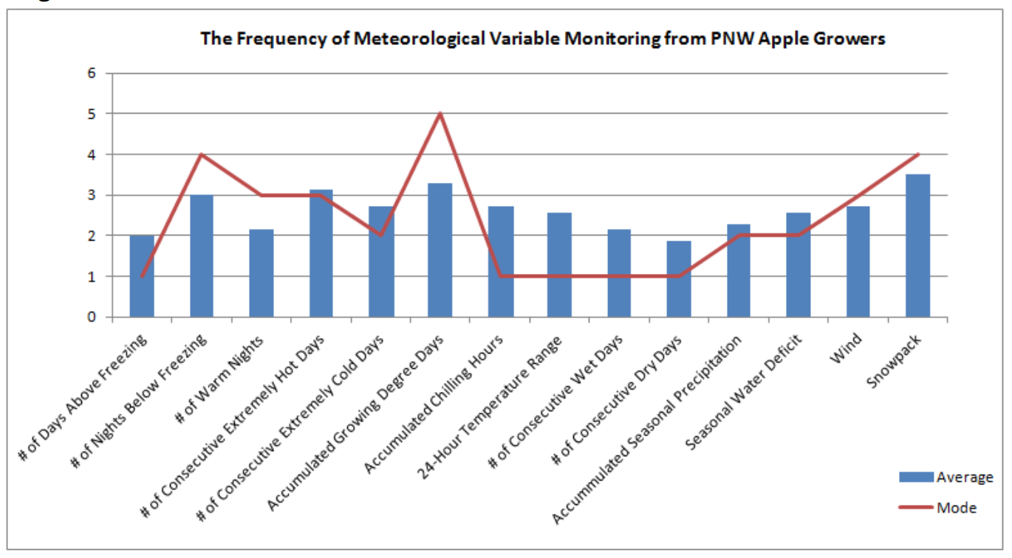

From this preliminary survey, apple growers indicated that they most frequently monitored snowpack, accumulated growing degree days, the number of consecutive extremely hot days, and the number of nights below freezing. The “number of accumulated growing degree days” had the most agreement amongst growers at the highest rating level, as 43% of growers rated the variables as a 5. The “number of days above freezing” variable had the most agreement at the lowest rating level, as 71% of growers rated the variable as a 2 or below. The frequency in which growers monitored snowpack may be inflated due to the record low snowpack during the 2015 growing season, with 71% of growers rating their monitoring frequency at a level of 3 or higher.

The most useful threshold information was obtained for variables that had higher mode values (with the exception of wind). This is in part because participants were only asked to identify thresholds for highly rated variables (i.e., ratings of 4 or 5). There was an option for participants to include additional thresholds or information, but the majority of participants only outlined thresholds for the most significant variables. Figure 2 summarizes the grower-defined thresholds and comments about each respective variable found through this questionnaire.
Figure 2
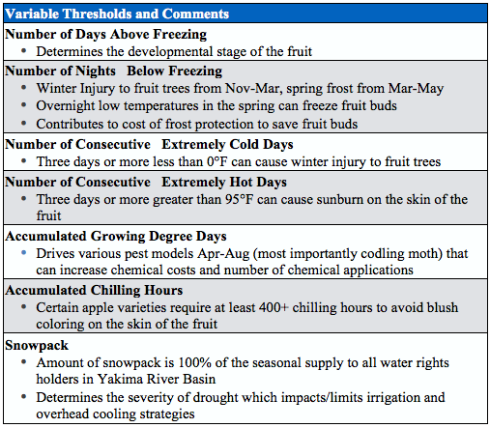

With these grower-defined thresholds, it is now easier to analyze climate models with respect to the variables that apple growers would be interested in knowing more about. In this study, the thresholds defined for the “number of consecutive extremely cold days,” the “number of consecutive extremely hot days,” and “accumulated growing degree days” were queried in climate models and analyzed more thoroughly.

Threshold Analysis
The selected grower-defined thresholds were queried in a 20-member climate model ensemble with 4-km resolution over the 90-year period from 1970-2059. A model ensemble is a group of climate models that each account for slightly different physics in the climate system. The resulting ensemble output is achieved when each of these models is given the same initial conditions. This output can then be searched, or queried, for the occurrence of a given meteorological event. In this study, the ensemble models are queried for the Wenatchee, WA area are based in the grid box in which the Wenatchee Heights weather station is located (47.37, -120.31). The plots in Figure 3 and Figure 4 show the simulated historical and future average number of heat waves/cold snaps per year using the grower thresholds in the region. The plots display the frequency of modeled past and future occurrence of such events. Each event that satisfies the threshold for three or more days is counted as one event. All events are unique, meaning that a 6-day event is only counted once rather than as two 3-day events.

The bars show the 20-model mean. The error bars on each plot outline the minimum and maximum values produced from the group of all ensemble members. Each plot offers model output for a low green house gas (GHG) emissions scenario and a high GHG emissions scenario.

Number of Consecutive Extremely Cold Days
Based on the output from the 20-member ensemble model, Figure 3 indicates the number of cold snaps projected to occur per year in Wenatchee, WA.
Figure 3
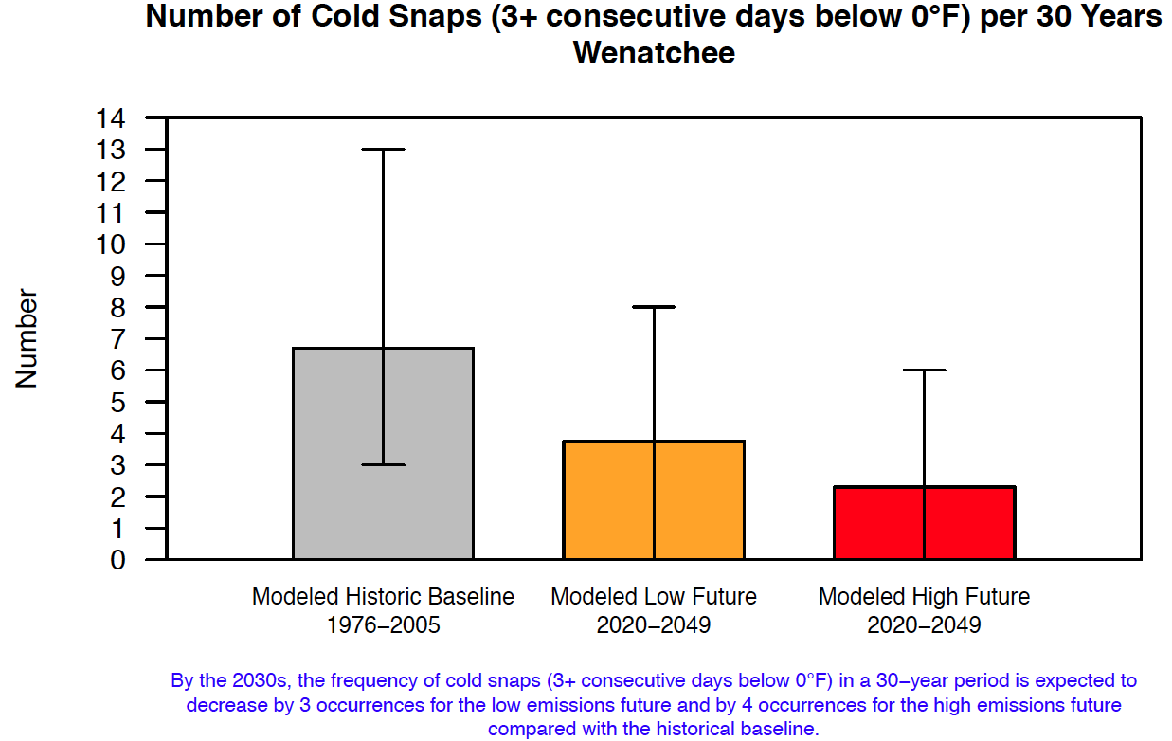

In the plot, a cold snap is defined as three or more consecutive days with low temperatures below 0°F (as defined by the growers) in a 30-year period. The number of cold snaps decreases by three occurrences per year in the low GHG emissions scenario and by four occurrences in the high emissions scenario, as compared to the historical model. The historical model further indicates that there were approximately seven cold snaps of this type in the time period from 1970-1999. This decrease in the number of cold snaps will lessen the likelihood of losing apple trees in the Wenatchee area due to winter injury, which “can reduce yields, kill the tree immediately, or cause a shorter tree life expectancy” (Huffman, 2015). This climate trajectory represents an overall benefit for PNW apple growers in the future.

Number of Consecutive Extremely Hot Days
In a similar fashion, the ensemble model was also queried for the number of grower-defined heat waves that may occur in the future, based on two different emissions scenarios. Figure 4 indicates the future frequency of heat waves of three or more consecutive days with high temperatures of 95°F or above.
Figure 4
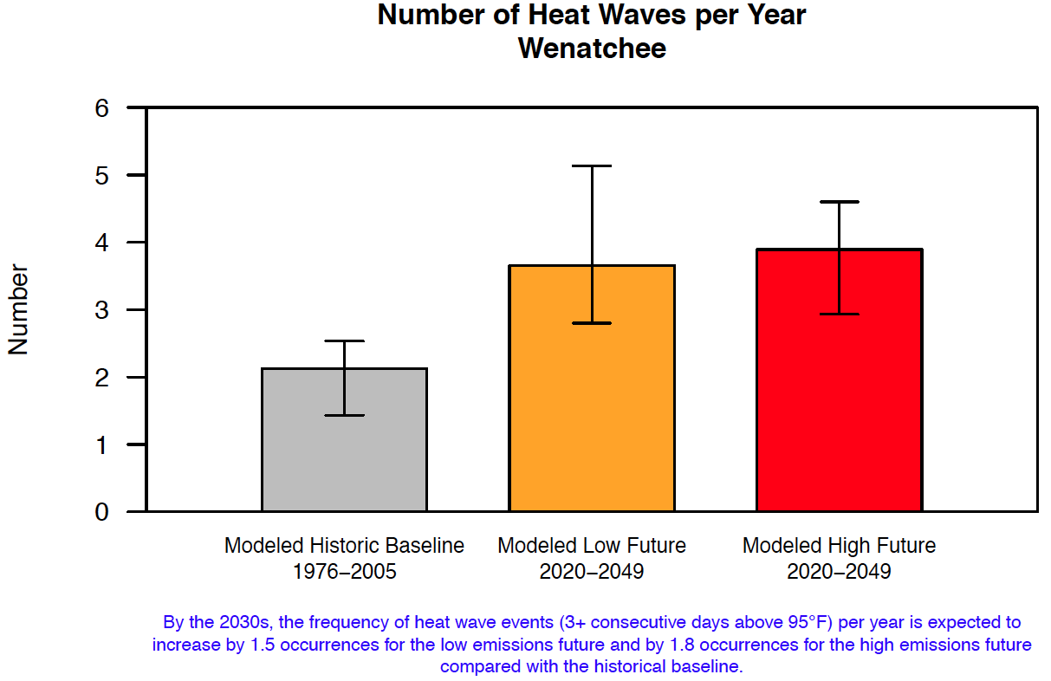

This plot shows that in the low and high emissions scenarios, growers can expect the number of heat waves per year to increase 1.2 and 1.8 per year, respectively, compared to the historical model.

As explained by the growers, heat waves of this kind can lead to sunburn on apples, which effectively lowers the grade and number of packed boxes of apples sold in the fresh market, thereby decreasing the total revenues that growers can receive for the crop. This threshold was also confirmed by previous research done by Schrader et al at Washington State University in 2003. Schrader’s study found that the sunburn browning occurs generally between 46°C and 49°C depending on cultivar (Schrader et. al, 2003). It is also important to note that Brooks and Fisher (1926) found that the temperature on the sun-exposed side of apples can reach 14°C above ambient air temperatures. Similarly, growers in this study reported that ambient air temperatures of >95°F (= >35°C) for three consecutive days pose an immediate sunburn threat to apples. This point coincides with the previously mentioned research, as a threshold of 35°C would bring sun-exposed sides of apple skin to temperatures of approximately 49°C, largely above the minimum threshold for sunburn browning as defined by Schrader et al. This research along with the survey data indicates that growers can expect to experience an increased amount of sunburn events into the future.

Accumulated Growing Degree Days
The number of Accumulated Growing Degree Days (AGDD) is expected to increase into the 2070s. Figure 5 outlines potential AGDD in Wenatchee, WA for high and low emissions scenarios.
Figure 5
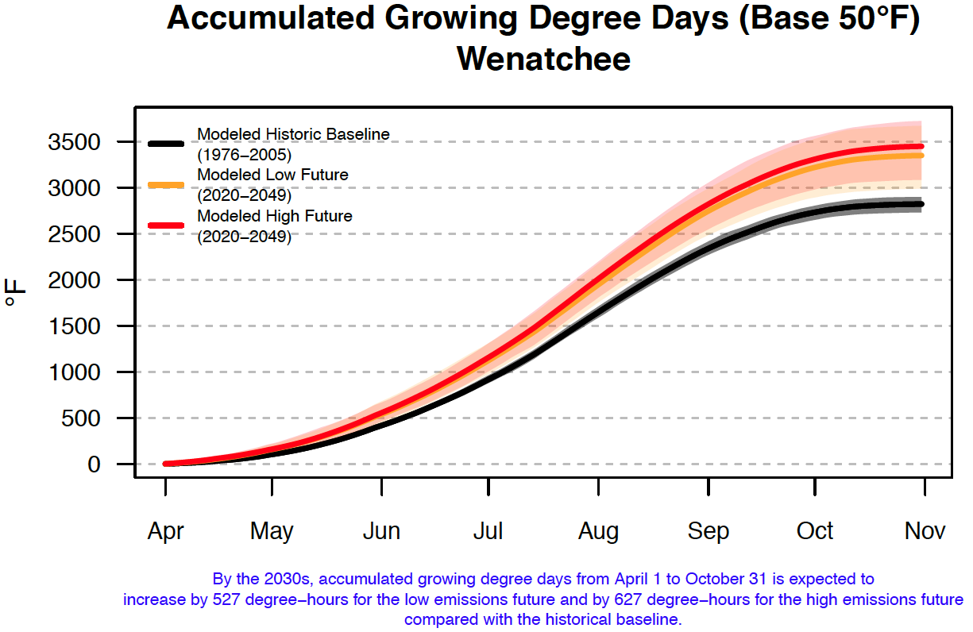

The modeled baseline shows an average maximum of approximately 2300 AGDD at the beginning of September. This average increases to approximately 2600 AGDD under low emissions scenarios and up to 2800 AGDD under high emissions scenarios.

As growers noted, AGDD is used as an input into pest models. The codling moth tends to be the most commonly modeled pest by apple growers, especially between the months of April and August. The codling moth model is based on a series of biofix events, which are determined by the number of accumulated growing degree days. For the codling moth, these biofix events are said to occur when there are five or more moths caught in a pheromone trap, set by the grower (McCamant, 2007).

With the projected increase in growing degree days in the future, pesticide costs and the number of chemical applications to control insects will also increase. In the historical model of AGDD, growers would see at least two biofix dates. In the modeled future, growers can expect to see three biofix dates more regularly. This increase in the number of spray events could effectively increase insecticide costs up to 50% for the codling moth.

An AgBizClimate Analysis
To take some control over the costs and returns associated with the aforementioned variables attributed to climate change, AgBizClimate can be utilized. AgBizClimate is a specially designed decision tool that allows growers to analyze and modify their budgets based on specified climate models.

To begin an AgBizClimate analysis, the grower selects previously generated enterprise budgets from AgBiz Logic that best reflect their personal economic situation, whether it’s actual grower data or representative returns and costs from readily available university budgets. These budgets serve as a baseline for the analysis once weather variables are introduced.

Next, AgBizClimate allows users to select the state and weather station that is closest to their location to generate downscaled, site-specific weather forecast information that denotes how climate change will impact their area. After selecting the weather station, the user can select three weather variables that they believe will most impact their yields or quality of their product, such as those noted previously.

Users can then modify future yields based on crop models, grower focus groups and specified weather variables. Figure 6 shows the options available to modify yields and the results of a user’s estimate of yields based on climate change impacts to Gala apples in Wenatchee, Washington. Currently there are no crop models that estimate changes to fruit quality (as it relates to percentage of fruit sold in a particular market) and noted as NA. However, results from grower focus groups show that the number of packed boxes sold could decrease from 15 to 30 percent, resulting in the percentage of cull apples increasing by the same percentage at no monetary value to the grower. Budgets 2 and 4 are developed to decrease the percentage of No. 1 fruit sold by 30 percent. Budgets 3 and 5 show 15 percent decrease in No. 1 fruit. The user can also estimate how each weather variable impacts yield or fruit quality, which in this analysis ranges from +10 to -25 percent. These estimates depend on a user’s knowledge of how weather can impact yields for a particular crop. The important input in Figure 6 is the percentage in Your Changes. This is the value used to modify yields in all calculations in the analysis.

Figure 6
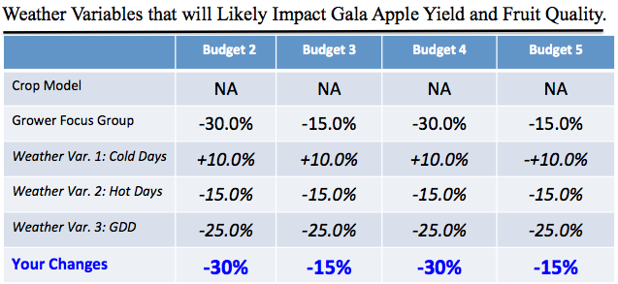

With AgBizClimate, users can modify selected inputs that increase or decrease costs, which are directly related to yields or product quality. For example, in this analysis inputs include increase in chemical costs and application rates. The user selects actual 2015 return and cost budget data for Gala apples (Budget 1). Then, modifying the budget with the assumptions shown in Figure 7, the user creates four additional budgets as shown below:
- Budget 1: Net Returns Before Climate Change Impacts
- Budget 2: Net Returns with 30% Reduction in No. 1 Grade Fruit, 50% Increase in Chemical Costs & Application Rates
- Budget 3: Net Returns with 15% Reduction in No. 1 Grade Fruit, 50% Increase in Chemical Costs & Application Rates
- Budget 4: Net Returns with 30% Reduction in No. 1 Grade Fruit, 25% Increase in Chemical Costs Only
- Budget 5: Net Returns with 15% Reduction in No. 1 Grade Fruit, 25% Increase in Chemical Costs Only

These budgets reflect a range of possible outcomes based on the information discussed earlier in Figures 3, 4 and 5.

Figure 7
Budget | Percentage of Apples Sold to Fresh Market | Number of Packed Boxes Sold/Acre | Percent of Number 1 Grade Fruit | Chemical Costs/Acre | Number of Chemical Application/Year | Annual Hours of Use/Acre  Tractor/Sprayer
1 | 73.00% | 1,204.50 | 60.00% | $1,100 | 15 | 9.24/4.76
2 | 52.63% | 868.39 | 39.63% | $1,650 | 22 | 13.56/6.98
3 | 62.05% | 1,023.83 | 49.05% | $1,650 | 22 | 13.56/6.98
4 | 52.63% | 868.39 | 39.63% | $1,375 | 15 | 9.24/4.76
5 | 62.05% | 1,023.83 | 49.05% | $1,375 | 15 | 9.24/4.76

Figure 8 shows the above results as an AgBizClimate output. Modifying the 2015 base budget (Budget 1) with the assumptions shown in Figure 7 decreases net returns for Gala apple producers by $7,669 per acre ($10,503 minus $2,834) under Budget 2 assumptions (30% reduction in No. 1 grade fruit, 50% increase in chemical costs and application rates). Under Budget 3 assumptions, grower net returns decrease by $4,535. Budgets 4 and 5 also decrease from the base budget by $7,147 and $4,013 per acre, respectively. In all four situations shown in AgBizClimate, the net returns per acre are much lower with the effects of climate change, proving that higher losses of packed fruit sold to the fresh market has a greater loss to net returns than additional chemical costs and application rates.

Figure 8
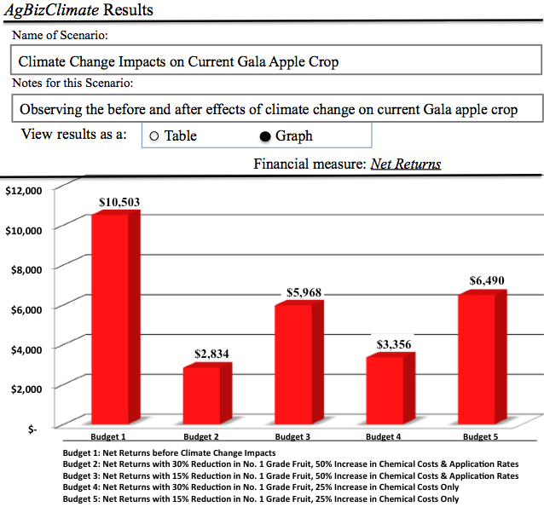

Concluding Comments
It has been shown through specific modeled climate variables that future weather will have a large impact on current agricultural practices and overall net returns in PNW apple orchards. With no changes in management practices, PNW apples will fare better during the winter months due to decreases in winter injury conditions to trees and will fare worse during the summer with an increased frequency of consecutive extremely hot days and accumulated growing degree days that affect fruit quality and insect pressures.

The effectiveness of incorporating a decision tool such as AgBizClimate has also been demonstrated. The downscaled information influences projected yield and production inputs that change over time. These yield changes are the impetus for producer-generated adjustments in input use, management and technology adoption that may lessen the negative impacts or take advantage of positive opportunities.

This article did not discuss adaptation strategies to mitigate the impacts of climate change. However, in focus group discussions, growers talked about two technologies that could be implemented to protect apples from the sun’s radiation – the use of shade netting and overhead cooling. The shade netting comes at a high cost, ranging from $10,000 to $15,000 per acre, while the overhead cooling is much less expense but requires higher amounts of water and could cause other defects in fruit quality. It is not the purview of AgBizClimate to compare the profitability of these two adaptation strategies. However, another soon to be released AgBiz Logic module, AgBizProfit, will allow users to conduct very extensive capital investment analyses to compare multiple near-term adaptation strategies to mitigate the impacts of climate change over time.
Acknowledgements
This project is made possible by contributions from:
- Oregon State University
- Oregon State University – College of Agricultural Sciences
- Oregon State University – Department of Applied Economics
- USDA Forest Service Northwest Regional Climate Hub
- USDA National Institute of Food and Agriculture – Award #2014-51181-22384
- USDA National Institute of Food and Agriculture – REACCH PNA

Special Recognition

Laurie Houston, Faculty Research Associate
Jenna Way, M.S. student, all in the Department of Applied Economics, Oregon State University
Dr. Beatrice Van Horne, USDA-Forest Service Leader of the NW Regional Climate Hub, Pacific Northwest Research Station

For More Information

Brooks, C., Fisher, D.F. (1926) Some high-temperature effects in apples: Contrasts in the two sides of an apple. J. Agr. Res. 32:1–16.

Brunner, J., & DeLong, F. (1990). Washington State Apple and Pear Pesticide Use Survey. Retrieved August 13, 2015, from http://www.tfrec.wsu.edu/pdfs/P8.pdf

Carlowicz, M. (2015, May 17). Diminished Snow Pack in the Pacific Northwest. Retrieved August 12, 2015, from http://earthobservatory.nasa.gov/IOTD/view.php?id=85887

Confirm 2F Label. (n.d.). Retrieved August 6, 2015, from http://www.gowanco.com/Document.aspx?id=955

eVegetation Manager (2013). Confirm 2F Insect Growth Regulator for Control of Lepidopteran Insects. Retrieved August 13, 2015, from
http://www.evegetationmanager.com/herbicides/confirm-2f-insect-growth-regulator qt.html

Gantla, S., Bernacchi, L., & Wulfhorst, J. (2015). Climate Change Risk Perceptions and Adaptive Strategies among Inland Pacific Northwest Wheat Producers.

Huffman, L. (2013, February 5). Weather Risks: Strategies to Mitigate the Risk of Winter Injury. Retrieved August 6, 2015, from http://www.omafra.gov.on.ca/english/crops/facts/weather-winter.htm#what

McCamant, T. (2007). Integrated Pest Management Manual for Minnesota Apple Orchards. Retrieved August 12, 2015, from https://www.mda.state.mn.us/news/publications/pestsplants/pestmanagement/ipm/ ipmapplemanual.pdf

Redfield-Wilder, J. (2015, June 26). Early water restrictions for eastern Washington irrigators. Retrieved August 12, 2015, from http://www.ecy.wa.gov/news/2015/086.html

Schrader, L., Zhang, J. and Sun, J. 2003. Environmental stresses that cause the sunburn of an apple. Acta Hortic. (ISHS) 618:397-405 DOI: 10.17660/ActaHortic.2003.618.47 http://dx.doi.org/10.17660/ActaHortic.2003.618.47

Seavert, C. (2015). AgBiz LogicTM. Retrieved August 4, 2015, from http://www.agbizlogic.com/

UC Management Guidelines for Codling Moth on Apple. (2011, August 1).
Retrieved August 6, 2015, from http://www.ipm.ucdavis.edu/PMG/r4300111.html

